1. What is Tree and Forest?

Tree

* In graph theory, a **tree** is an **undirected, connected and acyclic graph**. In other words, a connected graph that does not contain even a single cycle is called a tree.
* A tree represents hierarchical structure in a graphical form.
* The elements of trees are called their nodes and the edges of the tree are called branches.
* A tree with n vertices has (n-1) edges.
* Trees provide many useful applications as simple as a family tree to as complex as trees in data structures of computer science.
* A **leaf** in a tree is a vertex of degree 1 or any vertex having no children is called a leaf.

Example

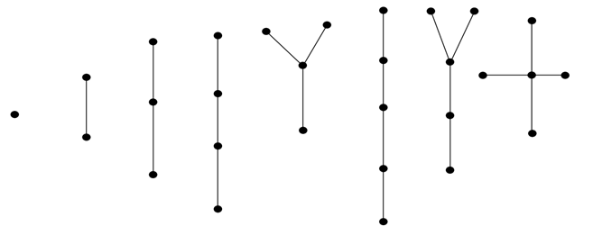

In the above example, all are trees with fewer than 6 vertices.

Forest

In graph theory, a **forest** is **an undirected, disconnected, acyclic graph**. In other words, a disjoint collection of trees is known as forest. Each component of a forest is tree.

Example

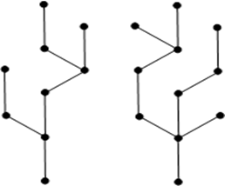

The above graph looks like a two sub-graphs but it is a single disconnected graph. There are no cycles in the above graph. Therefore it is a forest.

2. Properties of Trees

1. Every tree which has at least two vertices should have at least two leaves.
2. Trees have many characterizations:  
   Let T be a graph with n vertices, then the following statements are equivalent:
   * T is a tree.
   * T contains no cycles and has n-1 edges.
   * T is connected and has (n -1) edge.
   * T is connected graph, and every edge is a cut-edge.
   * Any two vertices of graph T are connected by exactly one path.
   * T contains no cycles, and for any new edge e, the graph T+ e has exactly one cycle.
3. Every edge of a tree is cut -edge.
4. Adding one edge to a tree defines exactly one cycle.
5. Every connected graph contains a spanning tree.
6. Every tree has at least two vertices of degree two.

3. Spanning Tree

A **spanning tree** in a connected graph G is a sub-graph H of G that includes all the vertices of G and is also a tree.

Example

Consider the following graph G:

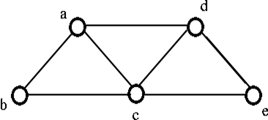

From the above graph G we can implement following three spanning trees H:

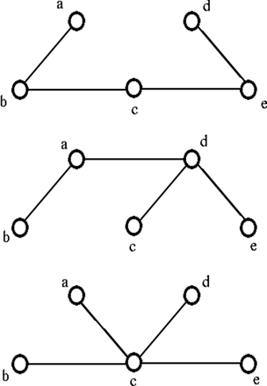

Methods to find the spanning Tree

We can find the spanning tree systematically by using either of two methods:

1. Cutting- down Method
2. Building- up Method

1. Cutting- down method

* Start choosing any cycle in Graph G.
* Remove one of cycle's edges.
* Repeat this process until there are no cycles left.

Example

* Consider a graph G,

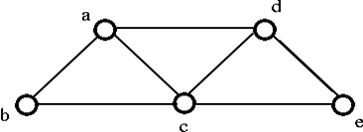

* If we remove the edge ac which destroy the cycle a-d-c-a in the above graph then we get the following graph:

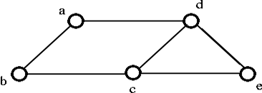

* Remove the edge cb, which destroy the cycle a-d-c-b-a from the above graph then we get the following graph:

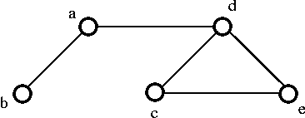

* If we remove the edge ec, which destroy the cycle d-e-c-d from the above graph then we get the following spanning tree:

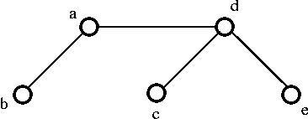

2. Building - up method

* Select edges of graph G one at a time. In such a way that there are no cycles are created.
* Repeat this process until all the vertices are included.

Example

Consider the following graph G,

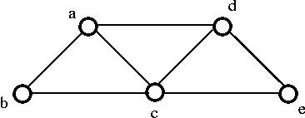

* Choose the edge **ab**,

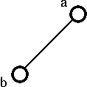

* Choose the edge **de**,

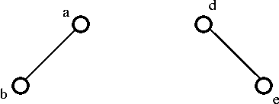

* After that , choose the edge **ec**,

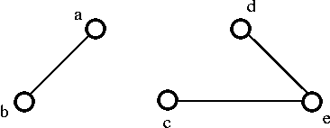

* Next, choose the edge **cb**, then finally we get the following spanning tree:

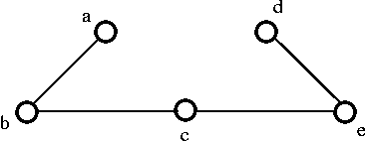

Circuit Rank

The number of edges we need to delete from G in order to get a spanning tree.

**Spanning tree G = m- (n-1)**, which is called the **circuit rank** of G.

1. Where, m = No. of edges.
2. n = No. of vertices.

Example



In the above graph, edges m = 7 and vertices n = 5

Then the circuit rank is,

1. G = m - (n - 1)
2. = 7 - (5 - 1)
3. = 3